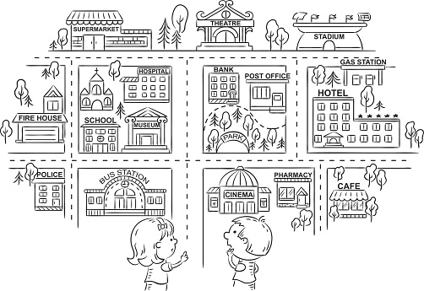

in front of opposite behind next to between

The bus station is ____________________ the police station and the cinema.

The school is ________________________ the museum.

The gas station is ____________________ the hotel.

The theatre is _______________________ the supermarket and the stadium.

The park is __________________________ the bank.

The hospital is _______________________ the museum.

The supermarket is ___________________ the theatre.

The stadium is _______________________ the gas station.

The church is ________________________ the school.

The post office is _____________________ the bank.

The café is __________________________ the hotel.

The pharmacy is _____________________ the cinema and the café.

The school is ________________________ the church.

The post office is _____________________ the park.

The museum is ______________________ the hospital.